USDA CACFP Food Guide Books

CACFP Crediting Handbook
* click on the link to get this manual.

https://fns-prod.azureedge.net/sites/default/files/resource-files/FNS_Crediting_Handbook.pdf

Food Buying Guide

* click on the link to get this document.

The FBG pdf is in YIELD DATA

https://foodbuyingguide.fns.usda.gov/Appendix/DownLoadFBG

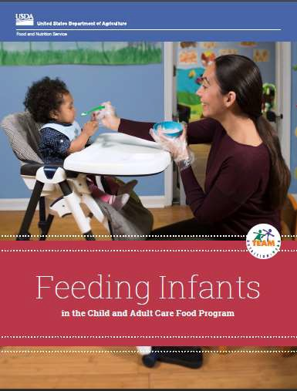

FEEDING INFANTS GUIDE
* click on the link to get this manual.

https://fns-prod.azureedge.us/sites/default/files/resource-files/FI_FullGuide_2021.pdf

